11/02/2026

Group 2:
Hasan Naimul
Piotr Zaprawa
Chiedozie Ezeogu
Lucia Martinez

Structure of the Interim Project Word Document:
- Introduction
Containing a description of our AdventureWorks2019 Database and tools used.

For each question:

- Question title

- Explanation
Containing an overview of the question and the steps taken to access the relevant information

- SQL code
Containing code and screenshots of relevant outputs of our code

- Visualisation and charts
Made with Python on VSC

- Python Code
Containing code and screenshots of relevant outputs of our code

- Insights
Containing business insights and conclusions on the specific question

Introduction: We are using the database AdventureWorks2019, which is a snowflake schema database, containing both tables and views → 71 tables, 20 views.
We used a combination of tools to draw insights from our data, such as SQL in SSMS, Python (VSC) packages such as Pandas, Matplotlib.pyplot and numpy to read dataframes and create visualisations. We have at times utilised Excel as well for an initial investigation of our tables.
1. What are the regional sales in the best performing country?
Explanation:
We have analysed and opened the first rows of the many tables of our dataset, and we found a table which could help us answer the question: Sales.SalesTerritory, where we have the Sales YTD and the Country Region Code. We now need the name of the country to which the code corresponds so we found another table which could be useful: Person.CoutryRegion which contains the Country Region Code and the Name of the country corresponding to the code.
SQL Code: First we need to know which country is the best performing → analysed later in question 3
SELECT SUM(t.SalesYTD) AS sum_sales, c.Name, t.CountryRegionCode
FROM Sales.SalesTerritory AS t
INNER JOIN Person.CountryRegion AS c
ON c.CountryRegionCode = t.CountryRegionCode
GROUP BY t.CountryRegionCode, c.Name
ORDER BY sum_sales DESC;
From the first part of our code we discover that the best performing country is the US. We can re-use this code in question 3.***
SELECT t.SalesYTD AS sales, t.Name
FROM Sales.SalesTerritory AS t
WHERE t.CountryRegionCode = 'US'
ORDER BY sales DESC;
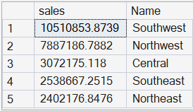
Insights:
From the second part of our code we discover the differences between regional sales in the US and we order them highest to lowest → Southwest (highest) to Northeast (lowest)
- One slide showing a Bar Chart with Sales YTD categorised by the different regions in the best performing country → clearly stating numbers or percentages by calculating the percentages directly in Python before plotting the bar chart
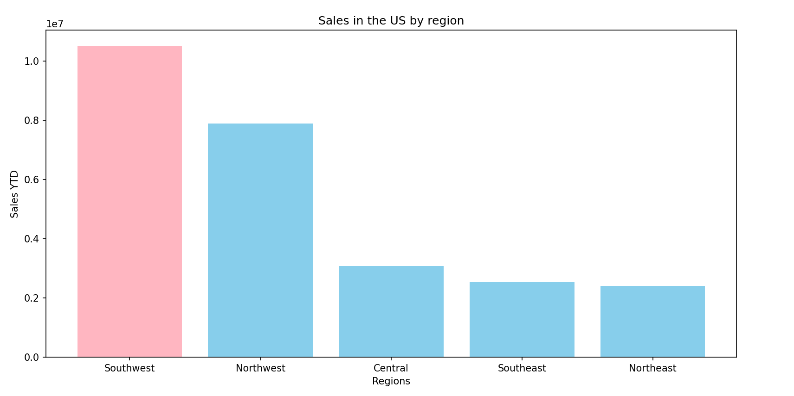
In order to do our visualisation we will have to save our SQL query output data in csv format and open it with Python VSC (importing pandas and matplotlib.pyplot).

Python Code:
import pandas as pd
import matplotlib.pyplot as plt
sales_US = pd.read_csv("question1_part2.csv", sep="\t")
print(sales_US)
sales_US = sales_US.set_index("Name")
colors = ['skyblue'] * len(sales_US)
colors[0] = 'lightpink'
plt.bar(sales_US.index, sales_US["sales"], color=colors)
plt.title("Sales in the US by region")
plt.ylabel("Sales YTD")
plt.xticks(rotation=0)
plt.xlabel("Regions")
plt.show()

Visualisation in percentage by region:
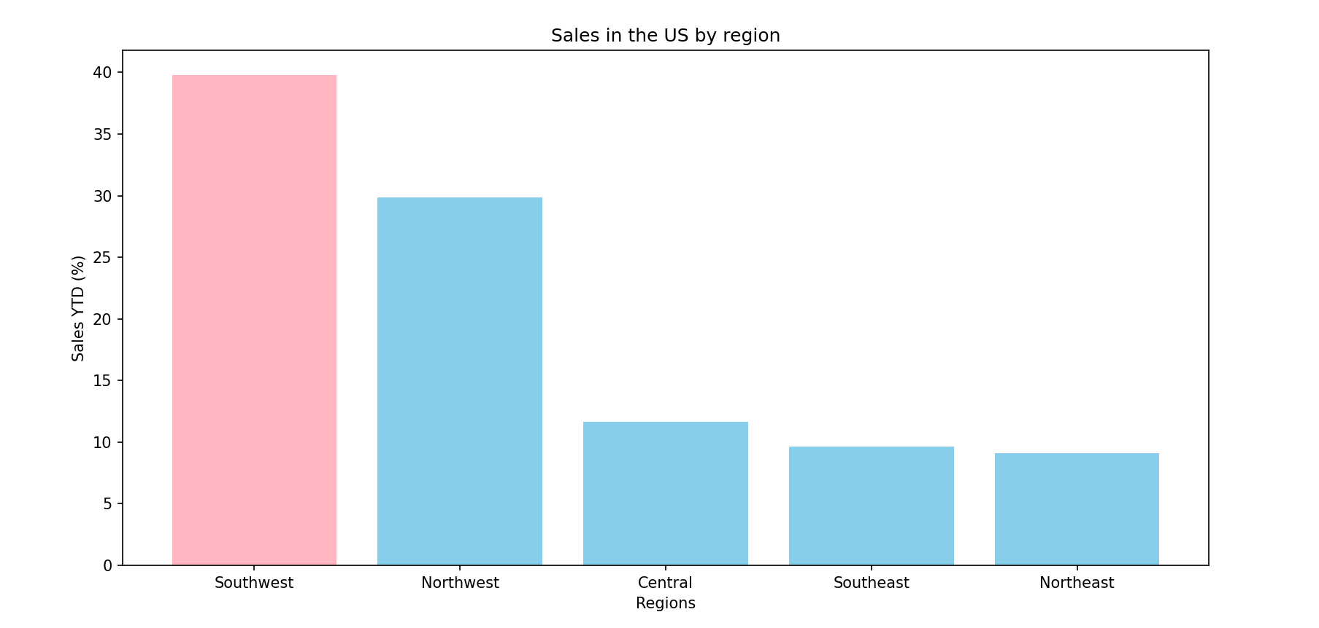
Python code:
We added the following code to make the graph showing percentages instead of absolute values.
sales_US["sales"] = sales_US["sales"]*100/(sales_US["sales"].sum())
print(sales_US)
Changing the name of the y label:
plt.ylabel("Sales YTD (%)")
Insights: → The best performing region is the Southwest with a percentage of almost 40% compared to the US total, followed by the Northwest with a percentage of almost 30%, whereas the lowest performance can be seen in the Northeast with a 9% YTD sales.
2. What is the relationship between annual leave and bonus?
Explanation:
To examine the relationship between vacation hours and bonus, we joined the HumanResources.Employee and Sales.SalesPerson tables using BusinessEntityID. VacationHours represents the remaining available vacation entitlement, while Bonus reflects performance-based compensation for sales employees.
SQL Code:
SELECT e.BusinessEntityID, e.VacationHours, sp.Bonus
FROM HumanResources.Employee AS e
INNER JOIN Sales.SalesPerson AS sp
ON e.BusinessEntityID = sp.BusinessEntityID;
Visualisation:
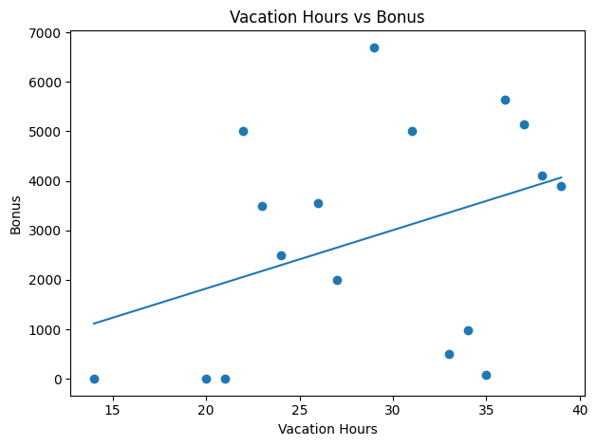

Python code:
import pandas as pd
import numpy as np
import matplotlib.pyplot as plt
# Load CSV
df = pd.read_csv("question2.csv", sep="\t")
# Ensure numeric columns
df["VacationHours"] = pd.to_numeric(df["VacationHours"], errors="coerce")
df["Bonus"] = pd.to_numeric(df["Bonus"], errors="coerce")
# Drop missing values
df = df.dropna()
# Correlation
corr = df["VacationHours"].corr(df["Bonus"])
print(f"Pearson correlation: {corr:.3f}")
# Scatter plot
plt.figure()
plt.scatter(df["VacationHours"], df["Bonus"])
plt.xlabel("Vacation Hours")
plt.ylabel("Bonus")
plt.title("Vacation Hours vs Bonus")
# Trend line
x = df["VacationHours"].to_numpy()
y = df["Bonus"].to_numpy()
m, b = np.polyfit(x, y, 1)
x_line = np.linspace(x.min(), x.max(), 200)
y_line = m * x_line + b
plt.plot(x_line, y_line)
plt.tight_layout()
plt.show()

Insights:
A correlation analysis shows that the relationship between vacation balance and bonus is weak, indicating that unused vacation entitlement is largely independent of bonus payments. A limitation of this analysis is that vacation hours reflect entitlement rather than vacation taken.
3. What is the relationship between Country and Revenue?
We will use sales.sales.territory table, (column country/region code) and (sales YTD) in SSMS. As explained above in Question 1, we also need the name of the country and we obtain this by performing an inner join with the table Person.CoutryRegion which contains the Country Region Code and the Name of the country corresponding to the code. We will then select our result as a table in the csv format, open it in VSC and create a bar chart.
SQL Code:
SELECT SUM(t.SalesYTD) AS sum_sales, c.Name, t.CountryRegionCode
FROM Sales.SalesTerritory AS t
INNER JOIN Person.CountryRegion AS c
ON c.CountryRegionCode = t.CountryRegionCode
GROUP BY t.CountryRegionCode, c.Name
ORDER BY sum_sales DESC;
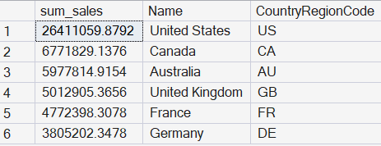
Visualisation:
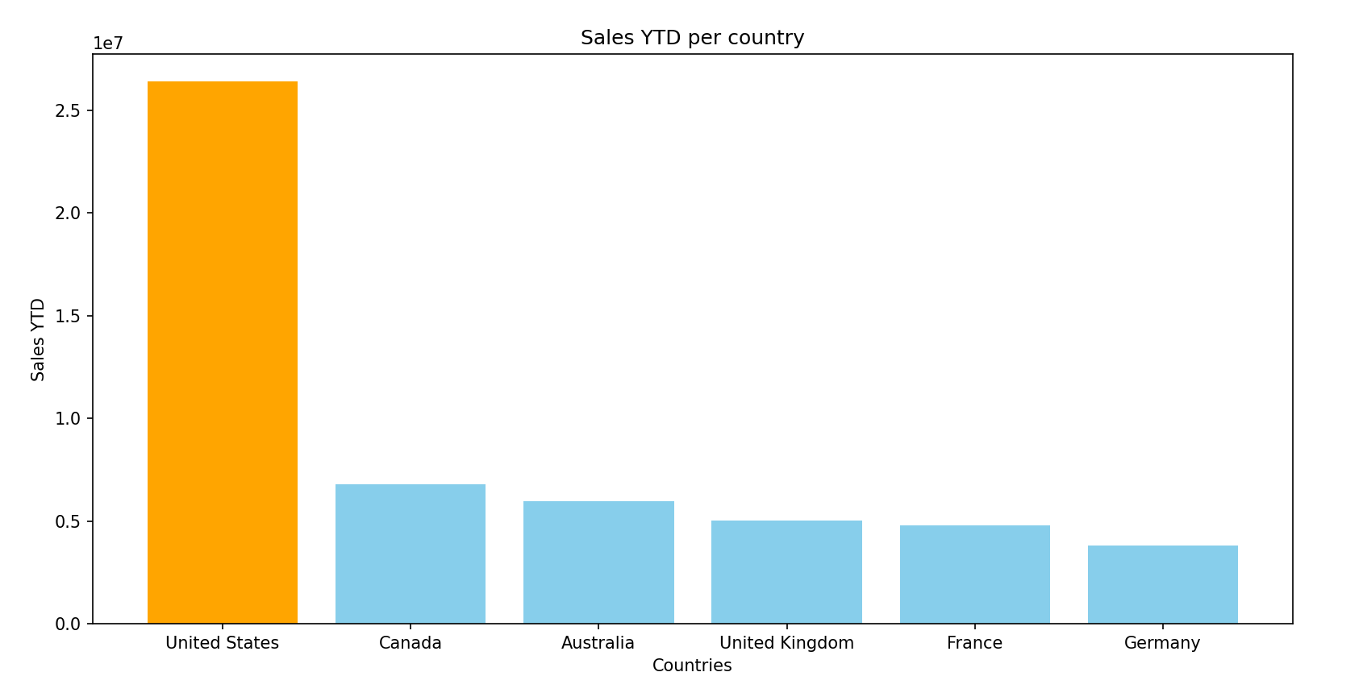
Python code:
import pandas as pd
import matplotlib.pyplot as plt
sales_by_country = pd.read_csv("question1_part1.csv", sep="\t")
sales_by_country.set_index("Name", inplace=True)
print(sales_by_country)
colors = ['skyblue'] * len(sales_by_country)
colors[0] = 'orange'
plt.bar(sales_by_country.index, sales_by_country["sum_sales"], color=colors)
plt.title("Sales YTD per country")
plt.ylabel("Sales YTD")
plt.xticks(rotation=0)
plt.xlabel("Countries")
plt.show()
Insights:
From our code and visualisations we discover that the best performing country is the US. We had to sum all the different regions (since they were separated in the data we were given). The United States is by far the country with the highest revenue.
4. What is the relationship between sick leave and Job Title (Person Type)?
Explanation:
Looking at the table (HumanResources.Employee) it contains columns called JobTitle and SickLeaveHours that will be useful to draw insights from in order to analyse the relationship between sick leave and job title. We had a think about whether the sick leave that we are considering is accrued or taken or which one would be more interesting to analyse. We ended up realising we only have information on the accrued leave and we will use this for our analysis.
A. Using SSMS we first want to show the number of employees in each job role and the sick leave accrued.
SQL Code:
SELECT JobTitle, count(*) AS employeecount, avg(SickLeaveHours) AS avgsickleave
FROM [AdventureWorks2019].[HumanResources].[Employee]
GROUP BY JobTitle
ORDER BY avgsickleave;
B. Showing the average time an employee has accrued for leave might not give us a comprehensive analysis. So we tried getting the min and max sick leave for each job title.
SQL Code:
SELECT JobTitle, MIN(SickLeaveHours) AS MinSickLeave, MAX(SickLeaveHours) AS MaxSickLeave, AVG(SickLeaveHours) AS AvgSickLeave
FROM [AdventureWorks2019].[HumanResources].[Employee]
GROUP BY JobTitle;
C. Getting the total average sick leave of the company
SQL Code:
SELECT AVG(SickLeaveHours) AS CompanyAvgSickLeave
FROM [AdventureWorks2019].[HumanResources].[Employee]
WHERE CurrentFlag = 1; → all our values have CurrentFlag=1
→ We can add a line saying WHERE SalariedFlag = 1 to describe only employees on salaries and differentiate them from hourly rate employees.
D. Visualizing the sick leave accrued by department so we can have a less cluttered report: we first need to perform an Inner Join on SQL to be able to group our average sick leave by department.
SQL Code:
SELECT
avg(e.SickLeaveHours) AS avgsickleave,
d.Department
FROM [AdventureWorks2019].[HumanResources].[Employee] AS e
INNER JOIN [AdventureWorks2019].[HumanResources].[vEmployeeDepartment] AS d
ON e.BusinessEntityID = d.BusinessEntityID
GROUP BY d.Department
ORDER BY avgsickleave;
Visualisation:
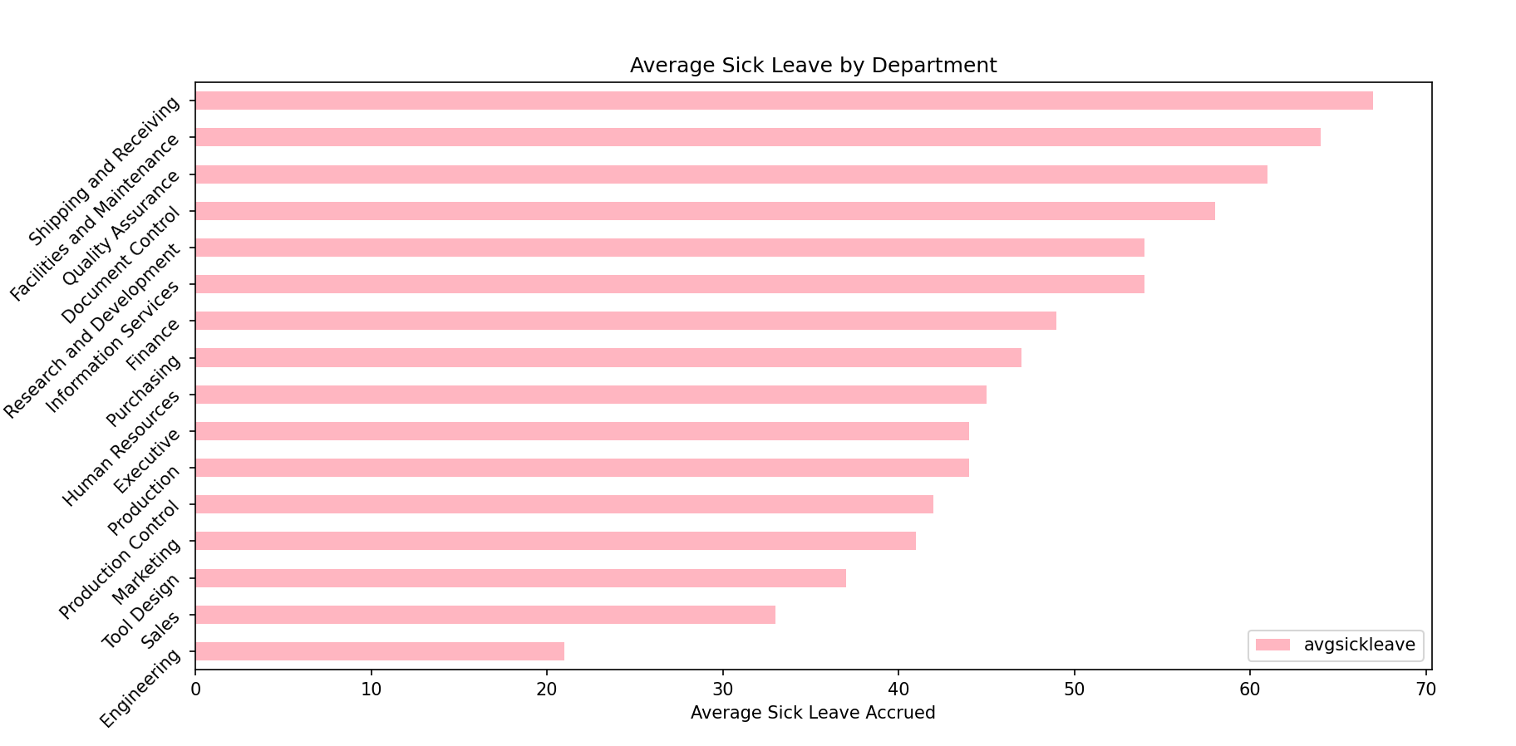
Python code:
import pandas as pd
import matplotlib.pyplot as plt
df = pd.read_csv("avgsickleave.csv", sep="\t")
df = df.set_index("Department")
print(df)
plt.figure(facecolor="lightblue")
df.plot(kind="barh", title = "Average Sick Leave by Department", color="lightpink")
plt.xlabel("Average Sick Leave Accrued")
plt.yticks(rotation=45)
plt.show()

Insights: Sick leave accrued seems to be different if we compare different departments but it does not seem to have a clear connection with the job title or with the seniority of the role.
From our bar chart above, we can clearly see the department which has accrued more sick leave on average is Shipping and Receiving (average of 67), while the department with the least amount of sick leave accrued is Engineering (average of 21).
By looking at the table below (grouped by Job Title with the top ten results below ordered from highest to lowest amount of hours of average sick leave), we can also conclude that seniority is not associated with higher accrued sick leave.
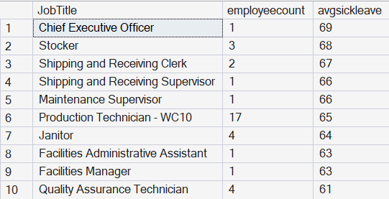
5. What is the relationship between store trading duration and revenue?
Explanation:
We found out that the information on store trading duration can be found by subtracting the year the store was opened from 2019. The information on when the store was opened can be found in Views (Sales.vStoreWithDemographics), as well as the annual revenue of the specific store - which we assume to be the yearly income of the typical customer of each store (averaged).
SQL Code:
SELECT AnnualRevenue, (2019 - YearOpened) AS duration
FROM Sales.vStoreWithDemographics
ORDER BY AnnualRevenue DESC;
→ Here are the first ten results of our code. If we wanted to group by Annual Revenue we would see there are only 5 values of it, so it will make sense to show a bar chart and boxplot for this.
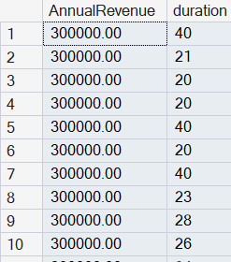
Visualisation: 1) Bar chart Average duration categorised by annual revenue band
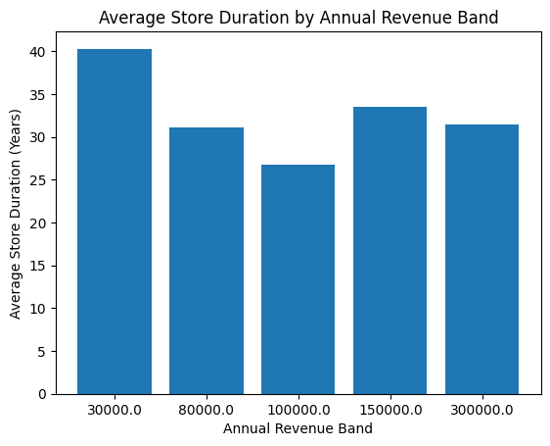
2) Box Plot Annual Revenue vs Duration
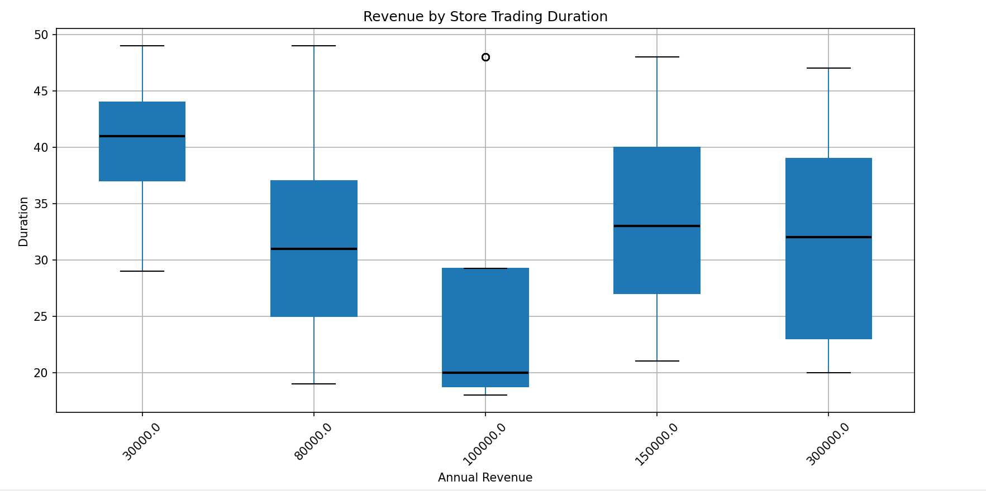
Python code for bar chart:
import pandas as pd
import matplotlib.pyplot as plt
# Load data
df_raw = pd.read_csv("AnnualRevenuevsduration.csv")
# Split the tab-separated column
df = df_raw["AnnualRevenue\tduration"].str.split("\t", expand=True)
df.columns = ["AnnualRevenue", "duration"]
# Convert to numeric
df["AnnualRevenue"] = pd.to_numeric(df["AnnualRevenue"])
df["duration"] = pd.to_numeric(df["duration"])
# Aggregate: mean duration per revenue band
grouped = (df.groupby("AnnualRevenue")["duration"].mean().reset_index())
# Bar chart
plt.figure()
plt.bar(grouped["AnnualRevenue"].astype(str), grouped["duration"])
plt.xlabel("Annual Revenue Band")
plt.ylabel("Average Store Duration (Years)")
plt.title("Average Store Duration by Annual Revenue Band")
plt.show()

Python code for boxplot:
import pandas as pd
import matplotlib.pyplot as plt
revenue_vs_duration = pd.read_csv("Question5.csv", sep="\t")
print(revenue_vs_duration)
revenue_vs_duration.boxplot(
column='duration',
by='AnnualRevenue',
rot=45, patch_artist=True,
medianprops={"color": "black", "linewidth": 2})
plt.title("Revenue by Store Trading Duration")
plt.suptitle("")
plt.xlabel("Annual Revenue")
plt.ylabel("Duration")
plt.show()
Insights from data:
We can see from our box plot that duration does not necessarily mean higher yearly income, it actually looks like between 30k and 100k income there is a decrease in duration (the newer stores make more money), but also we can gage that stores which have a customer base who makes 200k on average have been opened for longer than stores with a 100k-customer income.
It in fact looks like the stores with the highest customer income have been open for about 30 years (which is very close to the total average duration of all stores).
We could also add the mean on the boxplot and then our bar chart would not be necessary → we do this by adding showmeans=True in the argument of our Python code for the boxplot.
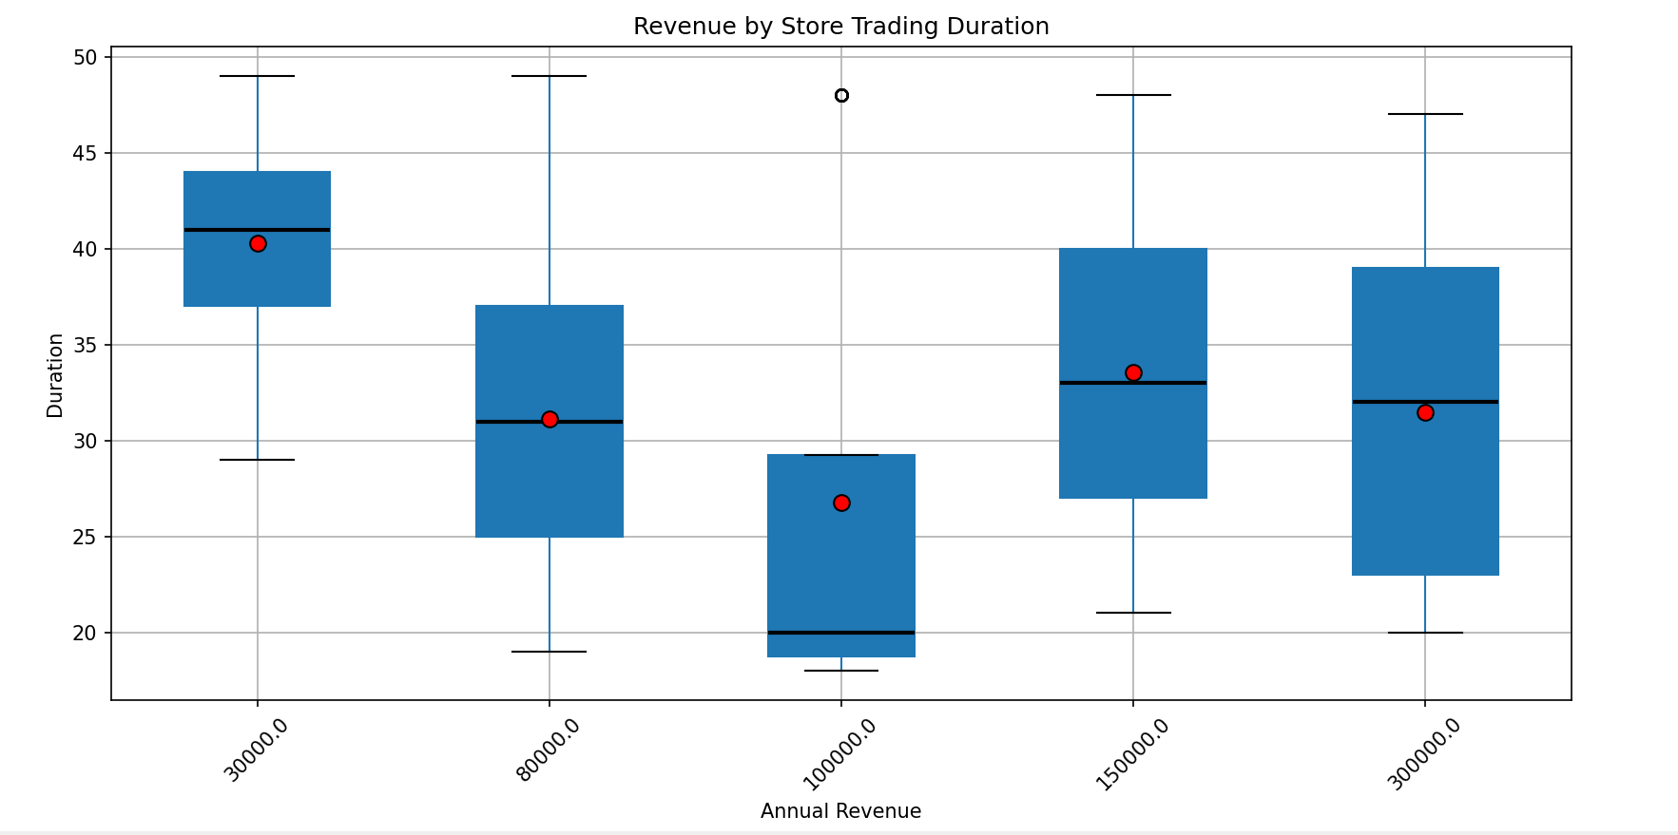

6. What is the relationship between the size of the stores, number of employees and revenue?
We can get this information from view: Sales.vStoreWithDemographics in our AdventureWorks 2019 Database which we have loaded in SQL SSMS.
SQL Code:
SELECT TOP (1000) [BusinessEntityID]
,[Name]
,[AnnualRevenue]
,[SquareFeet]
,[NumberEmployees]
FROM [AdventureWorks2019].[Sales].[vStoreWithDemographics]
→ To calculate correlation we save our results in a CSV file and import it in Python.

Python code:

import pandas as pd
import matplotlib.pyplot as plt
df = pd.read_csv("q6.csv")
print(df.head())
# Correlation - Shows very strong positive correlation between the variables
corr = df[["AnnualRevenue", "SquareFeet", "NumberEmployees"]].corr()
print(corr)

This is the resulting table:
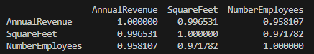
Insights:
We can see very strong positive correlation between the variables. We now want to have a bigger picture of the situation by calculating efficiency metrics.
# Efficiency metrics - Revenue per Employee and Revenue per Square Meter of store
df["RevenuePerEmployee"] = df["AnnualRevenue"] / df["NumberEmployees"]
df["RevenuePerSqFt"] = df["AnnualRevenue"] / df["SquareFeet"]
print(df[["RevenuePerEmployee", "RevenuePerSqFt"]].describe())

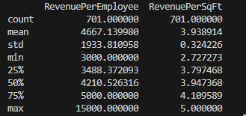

Insights:
While larger stores with more employees tend to have a higher revenue (yearly customer income), efficiency metrics show variation, indicating that size alone does not determine performance. Now we will visualize our results with charts.

Visualisation:

- Bubble chart: Shows the relation between all three variables: Revenue, Store size and Number of Employees

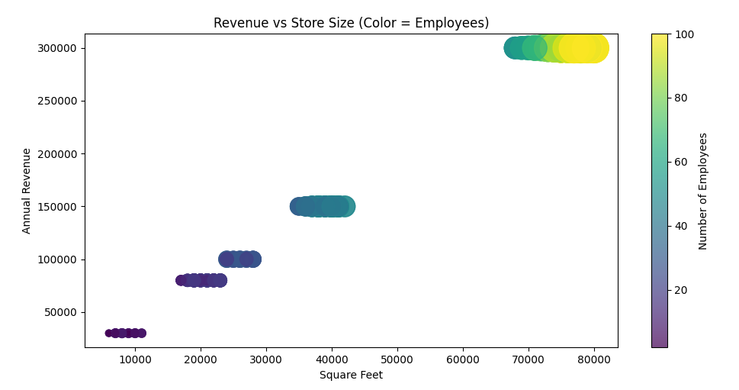
- Box Plot: Annual Revenue vs Number of Employees

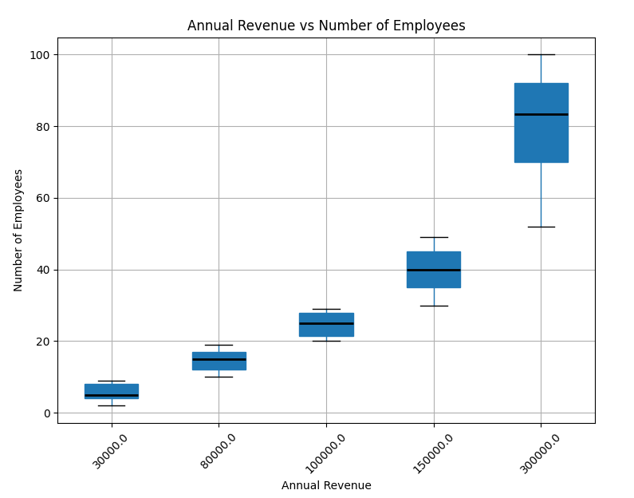

Python code for bubble chart:
plt.figure()
sc = plt.scatter(
df["SquareFeet"],
df["AnnualRevenue"],
s=df["NumberEmployees"] * 8,
c=df["NumberEmployees"],
cmap="viridis",
alpha=0.7
)

plt.xlabel("Square Feet")
plt.ylabel("Annual Revenue")
plt.title("Revenue vs Store Size (Color = Employees)")
plt.colorbar(sc, label="Number of Employees")
plt.show()

Python code for boxplot:

df.boxplot(
column='NumberEmployees',
by='AnnualRevenue',
rot=45, patch_artist=True,
medianprops={
"color": "black",
"linewidth": 2})
plt.title("Annual Revenue vs Number of Employees")
plt.suptitle("")
plt.xlabel("Annual Revenue")
plt.ylabel("Number of Employees")
plt.show()

Insights:
The charts show that some stores with 60 employees are related to an annual customer income of 300,000, instead of the typical 150,000, while some stores with 30 employees reach 150,000, instead of the typical 100,000. This indicates that deeper analysis is needed to understand the reasons behind these differences. Possible explanations include:
- High achievers: prime store locations, efficient management, and experienced staff.
- Low achievers: lack of staff or management training, potential overstaffing, or not optimal store locations.
Thank you so much for reading :)

